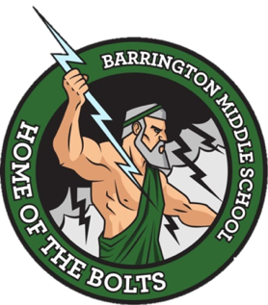

Barrington Middle School
SAC Agenda
November 16, 2022
Room 365

- Attendance

- Call to Order

- Approval or Correction of Minutes from October 26, 2022

- New Business
- Update on Barrington data (Ms. Cummings)
- Upcoming assessments

- Announcements (for the good of the group)
  - Next Meeting January 25, 2022 at 8:40 AM (No meeting in December) Have a happy holiday season!

- Adjournment

